SQL Assignment Solution

Submitted by : Sweta Dhara

1. Write a Query to list all the candidates possessing the skills- DS,Tableau,Python, SQL.

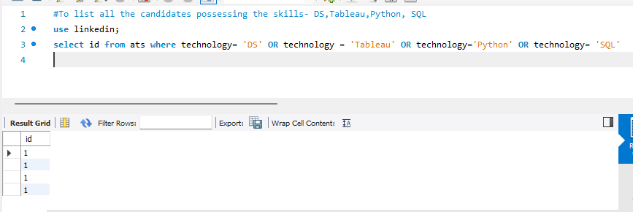

1. Write a Query to return IDs of product info that has 0 likes.

